
Federated healthcare cyber breach prediction system
Formal Methods (Term Project)

submitted to: Dr. abdul rehman
submitted by: Jawwad Ahmad (F25NDOCS3W04013) MSCS -2nd
The Islamia University of Bahawalpur, Bahawalnagar Campus

1. Introduction
The healthcare sector increasingly depends on digital technologies to store, manage, and exchange sensitive patient information. Electronic health records, clinical systems, and healthcare information platforms enable efficient medical services, but they also expose healthcare organizations to significant cybersecurity risks. In recent years, healthcare institutions have become major targets of cyberattacks that compromise confidential patient data and disrupt critical medical services. Healthcare data breaches not only threaten patient privacy but may also impact medical decision-making, financial stability, and even human lives that depend on the availability and integrity of medical information.
According to global digital security and ethical research principles promoted by international organizations such as the United Nations, protecting personal data and ensuring secure digital infrastructure are essential for safeguarding human welfare. Medical records contain highly sensitive information related to patient identity, diagnosis, treatment history, and financial records. Any compromise of such data can lead to identity theft, financial fraud, incorrect medical treatment, and potential harm to patients. Therefore, securing healthcare data is not only a technical requirement but also a responsibility toward protecting human lives and societal trust in digital healthcare systems.
This project proposes a Federated Healthcare Cyber Breach Prediction System that analyzes historical healthcare breach data to identify potential cyber threats. The system integrates advanced analytical components including data preprocessing, spiking neural networks for temporal pattern detection, federated learning for collaborative model training, and knowledge graph reasoning for explainable insights. By predicting cyber breach risks and providing interpretable threat intelligence, the system aims to support government health security authorities in issuing proactive cybersecurity alerts and guidelines to healthcare organizations, ultimately contributing to the protection of patient data and the safety of healthcare services.

2. Problem Statement
Healthcare organizations manage large volumes of highly sensitive information, including patient medical records, personal identification data, insurance information, and financial transactions. Because of the high value of this data, healthcare systems have become frequent targets of cyberattacks such as ransomware attacks, unauthorized access, phishing, and data theft. Cyber incidents can compromise patient confidentiality, disrupt hospital operations, and delay critical medical services that directly affect patient health and safety.
Many healthcare data breaches occur not only within hospitals but also through third-party service providers, commonly known as business associates, such as cloud service providers, IT vendors, and data processing companies that manage healthcare information systems. When these systems are compromised, attackers can gain access to large amounts of sensitive data. Furthermore, healthcare organizations often lack effective mechanisms to analyze historical breach data and detect emerging patterns that may indicate future cyber threats. Traditional security solutions typically focus on reactive responses after a breach has occurred rather than predicting risks in advance.
Given the increasing number of healthcare cyber incidents, there is a need for an intelligent framework capable of analyzing historical breach data, identifying attack patterns, and predicting potential cybersecurity risks before they cause significant harm. Protecting healthcare data is essential not only for maintaining patient privacy and financial security but also for ensuring that critical medical information remains accurate and available when human lives depend on it. Therefore, the proposed system focuses on developing a decentralized and privacy-preserving approach for predicting healthcare cyber breach risks and supporting government health authorities in making proactive cybersecurity decisions to safeguard patient data and healthcare infrastructure.

3. Rich Picture Diagram of the System
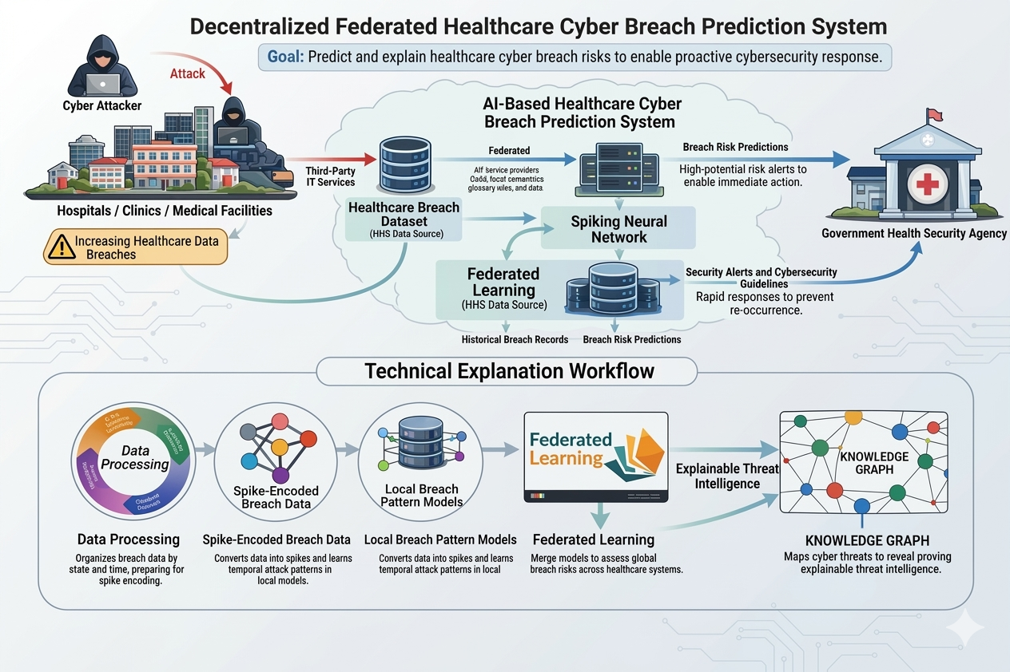

4. Formal Specification
Overview: This system applies federated learning (FL) to predict healthcare breach risk without sharing raw breach records across sites. FL enables secure, decentralized model training across institutions[1], so that each node trains on local HHS breach data (fields: State, BreachType, Location, BusinessAssociate, IndividualsAffected, grouped in 10-day TimeIntervals) and only shares model updates. In practice, FL “enables secure, decentralized training on patient data… preserving privacy and minimizing data breach risks”[2]. The specification below defines the data types, state variables, operations (with pre/post-conditions), and system invariants (safety and liveness).

Sets and Types
- State: the set of U.S. state identifiers (e.g., “MD”, “CA”, …).
- BreachType: enumeration of breach categories (e.g., Hacking/IT, Loss, Theft, UnauthorizedAccess, etc.).
- Location: set of breached-information locations (e.g., NetworkServer, Desktop, Paper/Films, etc.).
- BusinessAssociate: {Yes, No}, indicating whether a HIPAA business associate was involved (a “person or entity that performs functions involving disclosure of protected health information”[3]).
- IndividualsAffected: ℕ (non-negative integer count of persons impacted by a breach).
- TimeInterval: Ordered set representing 10-day time windows (t₀, t₁, t₂, …).
- Node: identifiers for participating local sites (one per state).
- Record: Tuple representing a breach entry:
$Record= \{State, BreachType, Location, BusinessAssociate, IndividualsAffected, TimeInterval\}$ for each reported breach.
- ModelParams: Set of valid machine learning model parameters.
- RiskScore: a real number in [0,1] indicating predicted breach risk level.
- Threshold: a fixed risk threshold $(0≤Threshold≤1)$ for alert generation.

System States
Local state (for node i)
- $Dataᵢ ⊆ Record$: the set of all breach records reported to node i, partitioned by 10-day intervals.
- $Modelᵢ ∈ ModelParams$: the current local trained model parameters at node i.
- $Predictionsᵢ : (State × BreachType × IndividualsAffected × TimeInterval)→ RiskScore$
Predictionsᵢ produces a risk score prediction for the given parameters.
- $Alertsᵢ$: list of alerts generated (entries (State, BreachType, IndividualsAffected, TimeInterval) where risk exceeded Threshold).
Global state (aggregator):
- $GlobalModel ∈ ModelParams$: the aggregated global model parameters (e.g. averaged from all nodes).
- $PendingUpdates : Node → ModelParams$
PendingUpdates stores model updates received from nodes before aggregation.

Operations
- ReportBreach(node, rec)
Pre-condition: $rec ∈ Record$
Post-condition: $Dataᵢ := Dataᵢ ∪ \left\{rec\right\}$
The new breach record is inserted into the dataset stored at $node_i$.
- TrainModel(node)
Pre-condition: $Data_i$ contains new breach records.
Post-condition: $Model_i$ is updated using the records in $Data_i$.
- SubmitModelUpdate(node)
Pre-condition: $Model_i$ has been trained.
Post-condition: $PendingUpdates[node]:= Modelᵢ$
- AggregateModels()
Pre-condition: $PendingUpdates ≠ ∅$
Post-condition: $GlobalModel := Aggregate(PendingUpdates)$
$$PendingUpdates := ∅$$
- DistributeModel()
Pre-condition: GlobalModel has been updated by an aggregation step.
Post-condition: For each $node_i$, $Modelᵢ := GlobalModel$ (nodes receive the new global parameters for the next round).
- PredictRisk(node, s, b, n, t)
Inputs:$$s ∈ State \\ b ∈ BreachType \\ n ∈ IndividualsAffected \\ t ∈ TimeInterval$$
Pre-condition: Node node has current model $Modelᵢ$.
Post-condition: Returns a $RiskScore = Modelᵢ(s, b, n, t)$
- GenerateAlert(node, s, b, n, t)
Pre-condition: A risk score $R = PredictRisk(node,s,b,n,t)$
Post-condition: $If R ≥ Threshold$
then $Alertsᵢ := Alertsᵢ ∪ \{(s, b, n, t)\}$

System Invariants
- Safety Invariants:
Data Privacy: Raw breach records $Data_i$ never leave their originating node. Only model updates (parameters) are communicated, so no sensitive breach information is shared[1]. This ensures compliance with HIPAA privacy rules.
Valid Data: For every record $r ∈ Dataᵢ$:
$$IndividualsAffected ≥ 0 \\ State ∈ State \\ BreachType ∈ BreachType$$
Model Consistency: Models are updated only through TrainModel() or AggregateModels() operations.
- Liveness Invariants:
Eventual Training: Every report of a breach is eventually included in a training execution at its node. I.e., as new records arrive, TrainModel will be called so that no data remains permanently untrained.
Eventual Aggregation: Local model updates from nodes are eventually aggregated into GlobalModel. In other words, after nodes submit updates, AggregateModels will produce a new global model that incorporates all submitted updates.
Alert Responsiveness: If the predicted risk for a (state, type, count, interval) exceeds the threshold, an alert will be raised in finite time by GenerateAlert.

Citations: Federated learning guarantees secure decentralized training without raw data sharing[1], which preserves privacy and reduces breach risk[2]. The BusinessAssociate field follows the HHS definition of a HIPAA business associate[3]. These invariants ensure the system behaves reliably and safely while performing breach risk prediction in a federated manner.
[1] Health-FedNet: A privacy-preserving federated learning framework for scalable and secure healthcare analytics - ScienceDirect
https://www.sciencedirect.com/science/article/pii/S2590123025025538
[2] Federated Learning in Smart Healthcare: A Comprehensive Review on Privacy, Security, and Predictive Analytics with IoT Integration - PMC
https://pmc.ncbi.nlm.nih.gov/articles/PMC11728217/
[3] Business Associates | HHS.gov
https://www.hhs.gov/hipaa/for-professionals/privacy/guidance/business-associates/index.html

